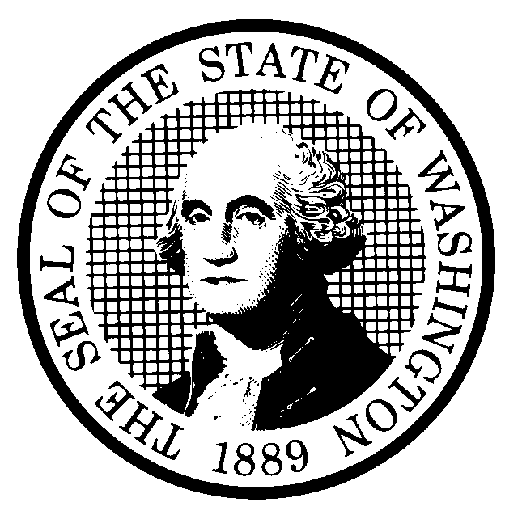 | EXPEDITED RULE MAKING |  |  | CODE REVISER USE ONLY
CR-105 (December 2017)
(Implements RCW 34.05.353)
Agency:
Title of rule and other identifying information: (describe subject)
Purpose of the proposal and its anticipated effects, including any changes in existing rules:
Reasons supporting proposal:
Statutory authority for adoption:
Statute being implemented:
Is rule necessary because of a:
Federal Law? |  |  |  |  | ☐ Yes | ☐ No
Federal Court Decision? |  |  |  |  | ☐ Yes | ☐ No
State Court Decision? |  |  |  |  | ☐ Yes | ☐ No
If yes, CITATION:
Name of proponent: (person or organization) |  |  |  |  | ☐ Private  ☐ Public  ☐ Governmental
Name of agency personnel responsible for:
 |  | Name | Office Location |  | Phone
Drafting:
Implementation:
Enforcement:
Agency comments or recommendations, if any, as to statutory language, implementation, enforcement, and fiscal matters:
Expedited Adoption - Which of the following criteria was used by the agency to file this notice:
☐ Relates only to internal governmental operations that are not subject to violation by a person;
☐ Adopts or incorporates by reference without material change federal statutes or regulations, Washington state statutes, rules of other Washington state agencies, shoreline master programs other than those programs governing shorelines of statewide significance, or, as referenced by Washington state law, national consensus codes that generally establish industry standards, if the material adopted or incorporated regulates the same subject matter and conduct as the adopting or incorporating rule;
☐ Corrects typographical errors, make address or name changes, or clarify language of a rule without changing its effect;
☐ Content is explicitly and specifically dictated by statute;
☐ Have been the subject of negotiated rule making, pilot rule making, or some other process that involved substantial participation by interested parties before the development of the proposed rule; or
☐ Is being amended after a review under RCW 34.05.328.
Expedited Repeal - Which of the following criteria was used by the agency to file notice:
☐ The statute on which the rule is based has been repealed and has not been replaced by another statute providing statutory authority for the rule;
☐ The statute on which the rule is based has been declared unconstitutional by a court with jurisdiction, there is a final judgment, and no statute has been enacted to replace the unconstitutional statute;
☐ The rule is no longer necessary because of changed circumstances; or
☐ Other rules of the agency or of another agency govern the same activity as the rule, making the rule redundant.
Explanation of the reason the agency believes the expedited rule-making process is appropriate pursuant to RCW 34.05.353(4):
NOTICE
THIS RULE IS BEING PROPOSED UNDER AN EXPEDITED RULE-MAKING PROCESS THAT WILL ELIMINATE THE NEED FOR THE AGENCY TO HOLD PUBLIC HEARINGS, PREPARE A SMALL BUSINESS ECONOMIC IMPACT STATEMENT, OR PROVIDE RESPONSES TO THE CRITERIA FOR A SIGNIFICANT LEGISLATIVE RULE. IF YOU OBJECT TO THIS USE OF THE EXPEDITED RULE-MAKING PROCESS, YOU MUST EXPRESS YOUR OBJECTIONS IN WRITING AND THEY MUST BE SENT TO
Name:
Agency:
Address:
Phone:
Fax:
Email:
Other:
AND RECEIVED BY (date)
Date:  Name:  Title: | Signature:  Place signature here

